**Activity diagram**:

Activity diagrams are mainly used as a flow chart consists of activities performed by the system. But activity diagram are not exactly a flow chart as they have some additional capabilities. These additional capabilities include branching, parallel flow, swim lane etc.

The basic purposes of activity diagrams are similar to other four diagrams. It captures the dynamic behavior of the system. Other four diagrams are used to show the message flow from one object to another but activity diagram is used to show message flow from one activity to another.

Activity is a particular operation of the system. Activity diagrams are not only used for visualizing dynamic nature of a system but they are also used to construct the executable system by using forward and reverse engineering techniques. The only missing thing in activity diagram is the message part.

It does not show any message flow from one activity to another. Activity diagram is some time considered as the flow chart. Although the diagrams looks like a flow chart but it is not. It shows different flow like parallel, branched, concurrent and single.

**Purpose:**

The basic purposes of activity diagrams are similar to other four diagrams. It captures the dynamic behavior of the system. Other four diagrams are used to show the message flow from one object to another but activity diagram is used to show message flow from one activity to another.

It shows different flow like parallel, branched, concurrent and single.Activity diagrams are mainly used as a flow chart consists of activities performed by the system. But activity diagram are not exactly a flow chart as they have some additional capabilities. These additional capabilities include branching, parallel flow, swim lane etc. . It captures the dynamic behavior of the system. Other four diagrams are used to show the message flow from one object to another but activity diagram is used to show message flow from one activity to another.

**REGISTATION ACTIVITY**

Get the Details

Validate Data

Invalid

Accept

Enter User Registration Details

Submit

No

Yes

Returns Error Message

Successfully Registered

**LOGIN ACTIVITY DIAGRAMS**

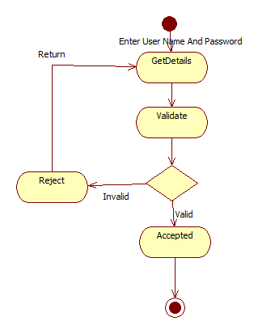

USER ACTIVITY DIAGRAM

